Latin America Name _________________ Num___
Glogster/Development Project

Go to Glogster.com, Click on the pink bubble on the right side of the screen – go to Glogster.com

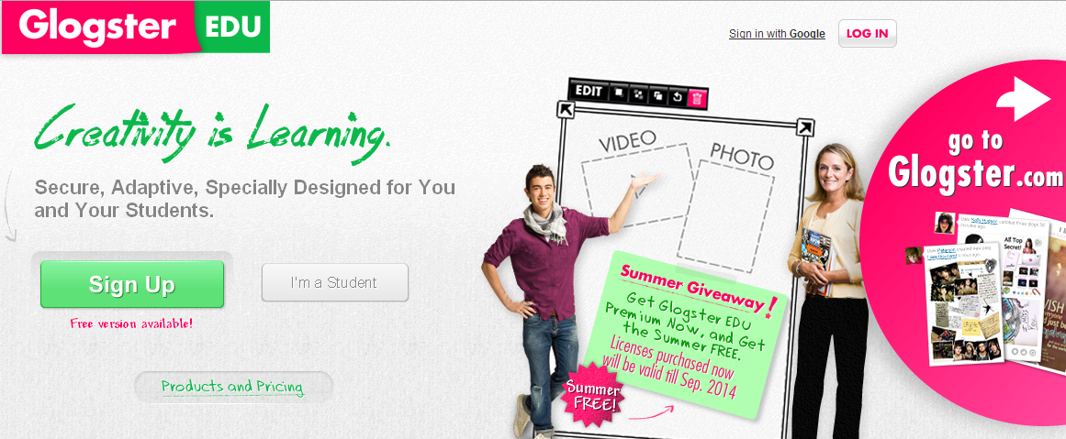

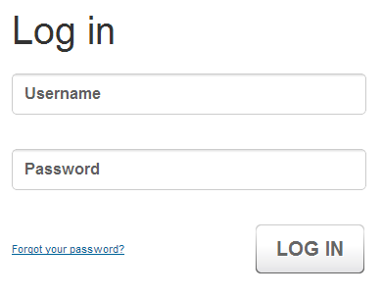

Log in information

Username – _______________
Password – _____________

This is ONE account everyone will use.
DO NOT change any of the acct settings.
This could lead to EVERYONE losing their projects.

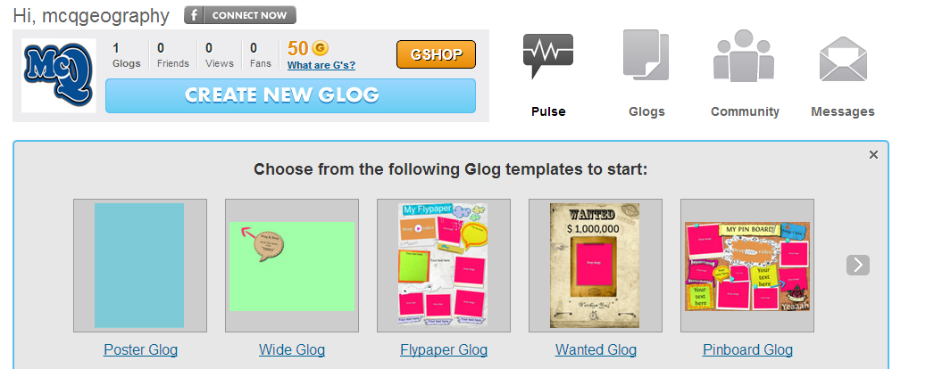
Step One – Create a new GLOG by
choosing the template you would
like. (go for blank and create your
own if you would like)

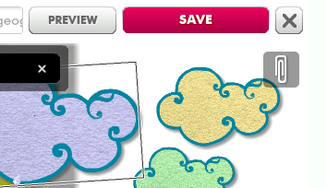
Click on your template and wait for
it to load. Once it has loaded, SAVE
it as your STU ID Per # and make it PRIVATE.

2116840 Per 3

Now, CREATE your Glog – with the information about Development. Be sure you include the following:

- Well-written explanation of development level with justifications
- Enhancements to support your above decision
  - Videos, pictures, links are all supporting enhancements

By Monday, October 21 – have your GLOG completed. AND comment on at least three others.
One positive comment and ask one question.
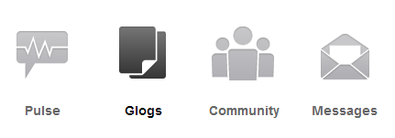
Only one can be in the same class. If a
GLOG already has five comments, move
to another one.
Be sure to sign your comment.

How to comment

Scroll down a little and the list of GLOGS will show up by the list.

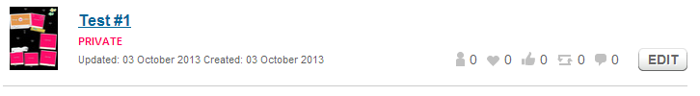

Once you have completed your GLOG – send me an email with your name and STUDENT ID#. Completed GLOGS by class time on Friday, October 11 will receive BONUS points. Any emails about completed Glogs AFTER this time will be scored on a regular scale.

I will respond to emails. If I don’t get your first email – screenshot your first attempt and try again!

ALL review due by Monday, Oct 21 by class time!

